## Introduction

In this project, we create a force measurement device from a Raspberry Pi, SingleTact sensor and electronics. Using Python code, the Pi continuously reads data from the SingleTact over I2C. The data are then plotted in real time on a connected display. The following sections describe how to correctly connect the SingleTact to a Raspberry Pi and install the software.

## Getting Started

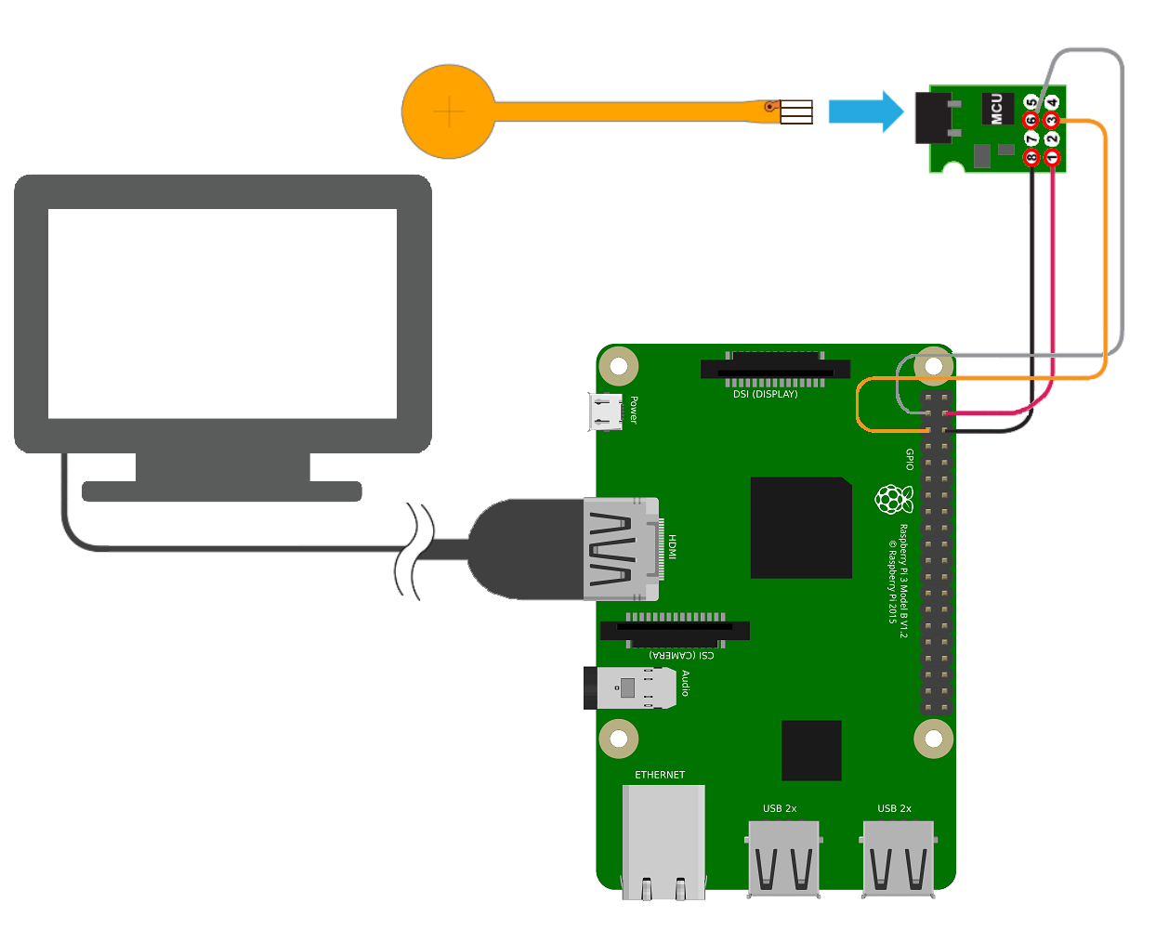Before you start, you will need:

* SingleTact sensor,
* electronics & jumper wires,
* Raspberry Pi;
* display device.

Connect the sensor into the FFC connector on the green interface board then, connect to the Raspberry Pi with four male-to-male jumper wires as shown.

## Configuring the Pi

Download the Raspberry Pi SingleTact demo software either directly from

<https://github.com/SingleTact/RaspberryPiDemo/releases/tag/v1.0>

or use git:

git clone https://github.com/SingleTact/RaspberryPiDemo

Install the following dependencies.

sudo apt-get install python-gi-cairo python-smbus i2c-tools

By default, I2C (the protocol used to communicate with SingleTact) is not enabled on the Pi. Enable it with the raspi-config tool.

sudo raspi-config

Select *Advanced Options* → *I2C* → *Enable/Disable automatic loading*, then select ‘yes’.

If running Raspbian releases before 3.18, edit the blacklist configuration as follows.

sudo nano /etc/modprobe.d/raspi-blacklist.conf

Comment out the following by adding a “#” to the start of each line.

blacklist spi-bcm2708

blacklist i2c-bcm2708

Reboot to allow system changes to take effect

sudo reboot

## Running the Software

The software can be launched directly from the terminal:

cd ~/RaspberryPiDemo

python pps-singletact.py

To create a log of all output data, launch the program in verbose mode with output redirected to a file:

python pps-singletact.py –v &>> my_output_file

To automatically launch the SingleTact software at startup, append a line to /etc/profile like this:

echo "python pps-singletact.py &" | sudo tee -a /etc/profile

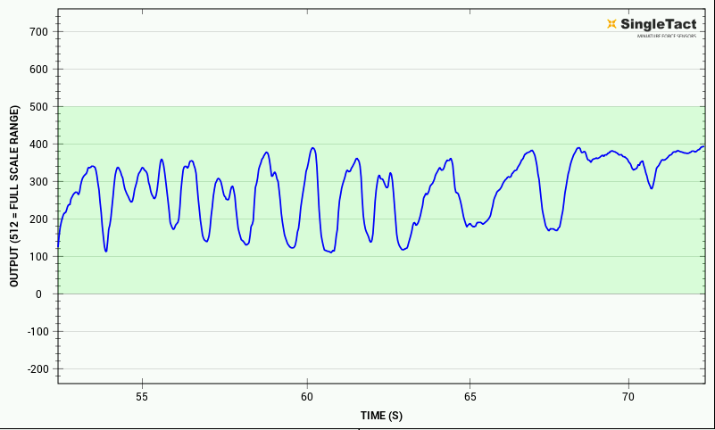

Please check the SingleTact Manual for trouble-shooting and more detailed information:

<http://www.singletact.com/SingleTact_Manual.pdf>